WEEK 4(OUTPUT SCREENSHOTS)

Account
Console output:
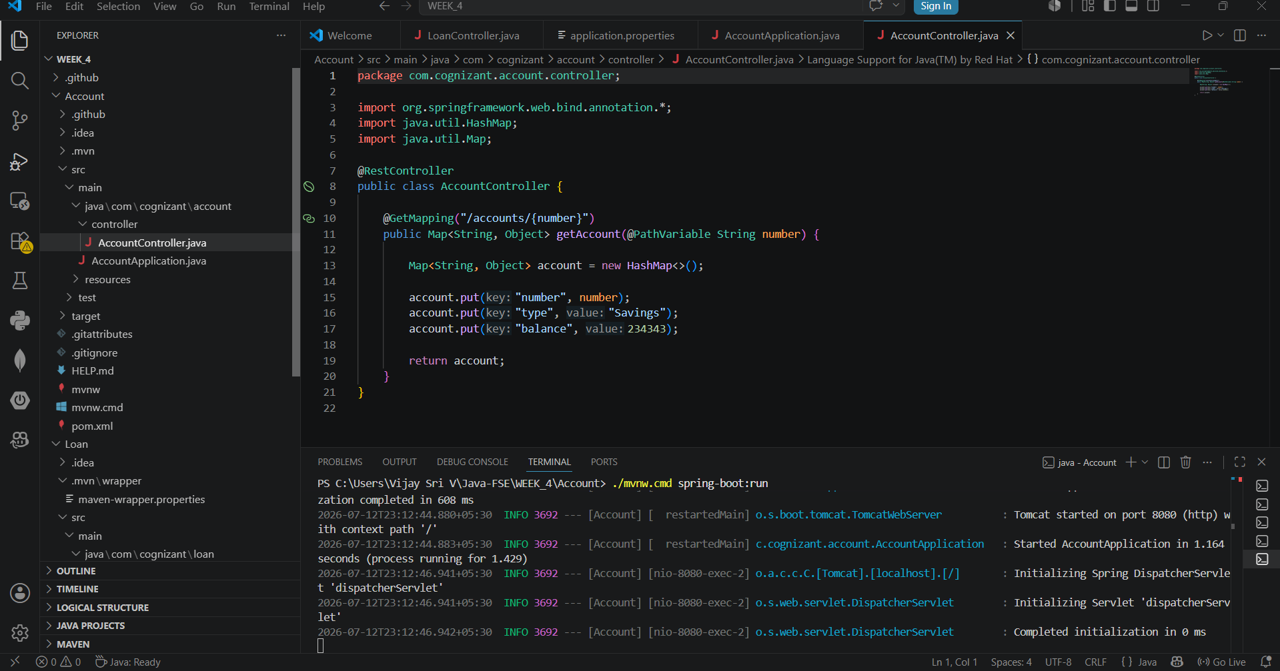

Browser Output

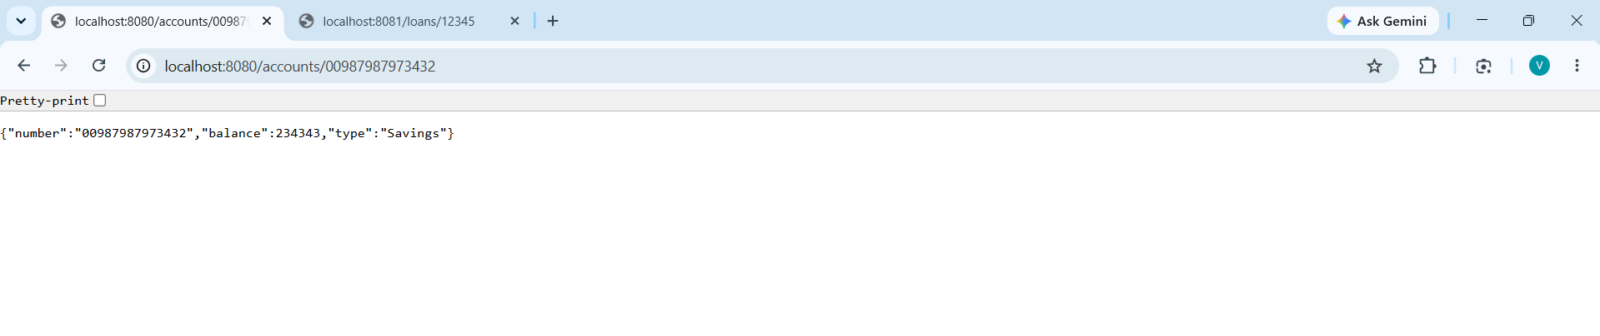

Loan
Console Output
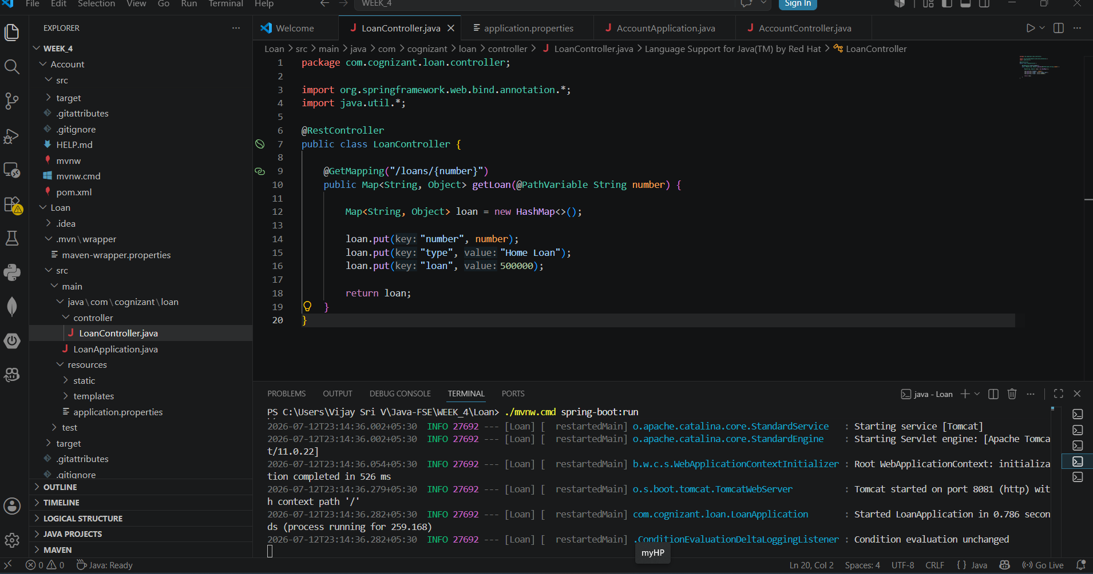

Browser Output

